### Requirement Model

### Use Case Model

After investigation of the requirements the following [Use Case diagram](https://media.discordapp.net/attachments/418342556800385048/433932325508743168/2_-_Use_Case_Diagram.png?width=720&height=585) has been developed to outlining the initial set of interactions required

.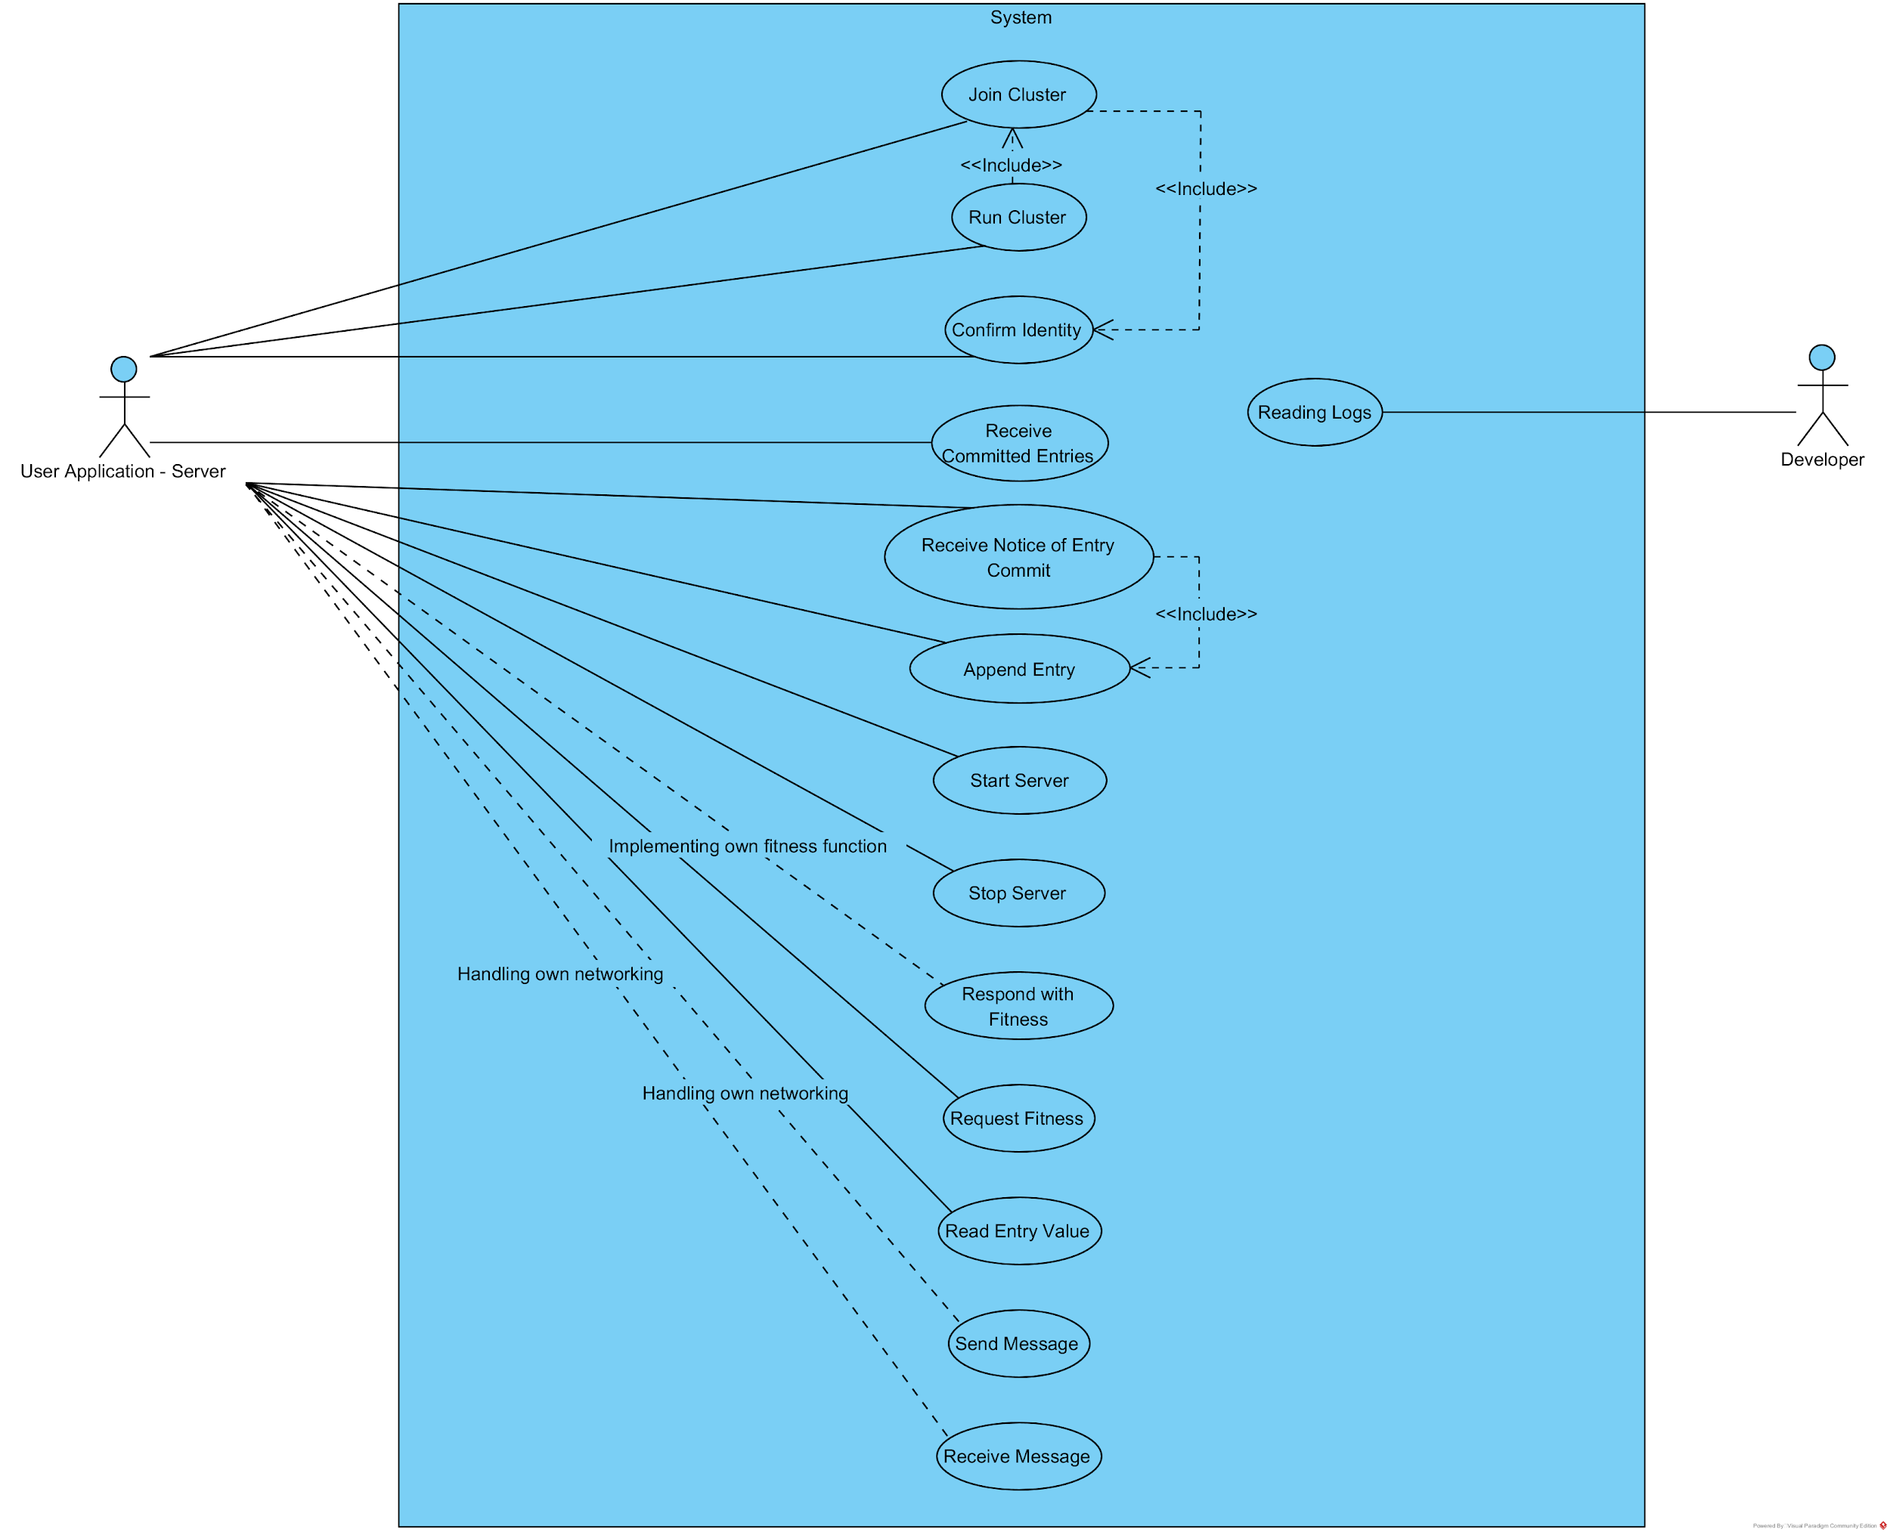

### Short Use Case Descriptions - In Table Form

#### Actor Key

UAS = User Application Server

Dev = Developer

|  |  |  |  |  |  |
| --- | --- | --- | --- | --- | --- |
| **Use Case Name** | **Precondition** | **Actor** | **Need** | **Do**  **Something** | **Basic Intent/Goal** |
| Join Cluster | Has information about the cluster | UAS | Join the cluster | Join Cluster | Become a member of the cluster |
| Run Cluster | Join Cluster use case has run | UAS | Participate in cluster actions | Run Cluster | Start participating in the cluster |
| Receive Committed Entries | N/A | UAS | Bring itself up to date | Receive Committed Entries | Can maintain consensus |
| Append Entry | N/A | UAS | To add a message into consensus | Append Entry | Message gets committed into the consensus |
| Receive Notice of Entry Commit | N/A | UAS | To know if the message they requested to be committed, was committed | Receive Notice of Entry Commit | So that they may update the running UAS state |
| Receive Start Server | The current node should be running a UAS | UAS | To be running a UAS when required | Receive Start Server | They may go ahead and start up their UAS to provide services |
| Receive Stop Server | The current node should stop running their UAS | UAS | To stop running a UAS when required | Receive Stop Server | They stop acting as a UAS and providing service |
| Respond with Server Fitness | UAS implementing own fitness function | UAS | Wants to respond with its fitness for being the UAS | Respond with Server Fitness | The most fit node may be identified to run the UAS |
| Read Entry Value | N/A | UAS | Read log entries that have been committed | Read Entry Value | Can reference the committed data |
| Send Network Message | Offloading node communication to UAS | UAS | Send a message offloaded to it from the underlying consensus algorithm | Send Network Message | The underlying consensus algorithm can still communicate without relying on it’s own networking stack |
| Receive Network Message | Offloading node communication to UAS | UAS | Forward a message offloaded onto it’s networking stack to the underlying consensus algorithm | Receive Network Message | The underlying consensus algorithm can still communicate without relying on it’s own networking stack |
| Confirm Identity | N/A | UAS | Confirm the identity a new node communicating for the first time | Confirm Identity | Establish security through trust, and ensure they cannot be MITMd |
| Read Logs | N/A | Dev | Understand what the underlying consensus algorithm is doing, perhaps tracking a bug | Read Logs | Understand what the underlying consensus algorithm is doing |

### Domain model

[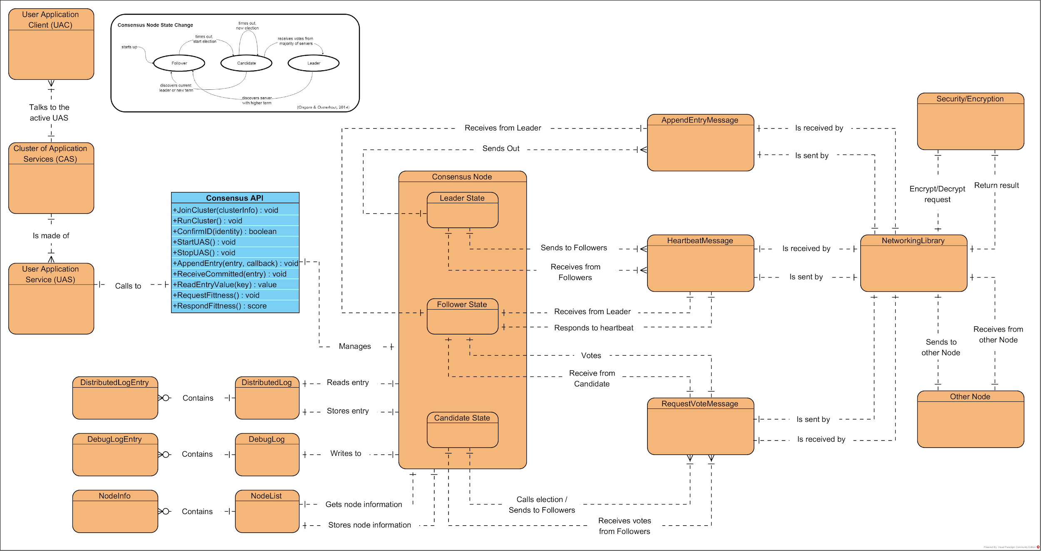](https://media.discordapp.net/attachments/418342556800385048/433932360279654410/2_-_Domain_Model.png?width=960&height=510)

#### 

#### Discussion regarding domain model

We’ve found this is easiest to explain using an example of a distributed multiplayer game running a which is in a server/client setup. In this example the server is also running on one of the clients. In that example, the UAC would be the game client which the player’s would be interacting with, and UAS would be the game server all the game clients are talking back to. Our library would be integrated into the UAS.

Reading from the top left of the diagram it’s shown how the UAC (i.e. game clients) talk to the active UAS (i.e. game server) in the Cluster Application Servers(CAS). Then it’s shown how the CAS is made up of UASs. It’s the library which links these UACs together into a cluster, and the UACs simply talk to whomever is the ‘leader’ UAS in the CAS. The UAC can simple just try each of the IPs in the CAS until they find the leader who responds, this cuts down on the complexity in the UAC software.

Next, the UAS uses the Consensus API to talk to it’s internal Consensus Node. This consensus node is the part that handles cluster operations, and part of that is instructing the UAS to let it know when it should and shouldn’t be running the active game server. The nodes all communicate to each other through messages which are sent and encrypted by the Networking Library. Consensus between the nodes is through a shared distributed log (DistributedLog) which the active UAS commits entries into, and the follower nodes are updated with. Each node stores information about the other nodes which are in the cluster with it. And each node does verbose logging for troubleshooting reasons.

#### Does the analysis of non-functional requirements demonstrate an ability to identify, quantify, prioritise, and communicate required system qualities? (LO2)

This is the part of the document where the above would be analysed, however after discussing with Jim, he has confirmed that this is covered by our ”Business Justification for Functional and Nonfunctional Requirements” section in the Project Vision above.